25.1.1 Editors - Properties Editor - Tools Tab - Object Mode
Object Mode - Options Panel 2
Transform 2
Affect Only 2
Origins 2
Location 2
Parents 2

Object Mode - Options Panel

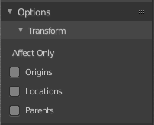
Transform

Affect Only
Here you can restrict the elements that moves when you move rotate or scale the object.

Origins
Move or rotate the origin instead of the object geometry. Scale has no effect. And it will not work on geometry like lamps.

Location
This is for having more than one object selected. Scales or rotates the selection instead of scaling or rotating the single objects. The single objects keeps their scale and their rotation.

Parents
Don't transform the child objects. Just the parent objects.

